**5.3 Determining internal resistance**  Name: __________________________

Score: _______ / 25

**Purpose:** To determine the amount of internal resistance present in a standard D battery.

**Background:** A battery is a device that maintains a steady voltage but this potential difference is not maintained indefinitely. Everyone has replaced a battery that has run down. Your cell phones indicate how long the battery will last before it will need to be recharged. Batteries set up a potential difference resulting in an electric field in the wires of the circuit.

They do this through a complex chemical reaction. As you may recall from chemistry class, no chemical reaction goes on forever. There is a limited amount of reactants contained inside your battery, and as those reactants start to run low the battery is no longer able to maintain the indicated voltage. For rechargeable batteries the chemical reaction is reversible. For non-rechargeable batteries, when the reactants are spent, the battery is dead. An old battery may be labeled 9.0 V, but a voltmeter will show that it can only maintain a voltage of 8.6 V.

Some of the energy given to circuits by a battery (or other source of EMF – electromotive force) is dissipated inside the cell itself, as the charge carriers move through the cell. What is left is available as a potential difference V across a circuit connected to the cell. If the EMF of the source is *E*, and its internal resistance is *r,* then when a current *I* flows the available potential difference *V* is *V = E – I r.*

Compare the equation *V = E – I r*  to y = mx + b. If current (*I*) is varied and potential (*V*) is measured, and a plot of *V* vs *I* is created, the slope of this plot will be –*r* and the y-intercept will be the EMF of the chemical reaction of the battery.

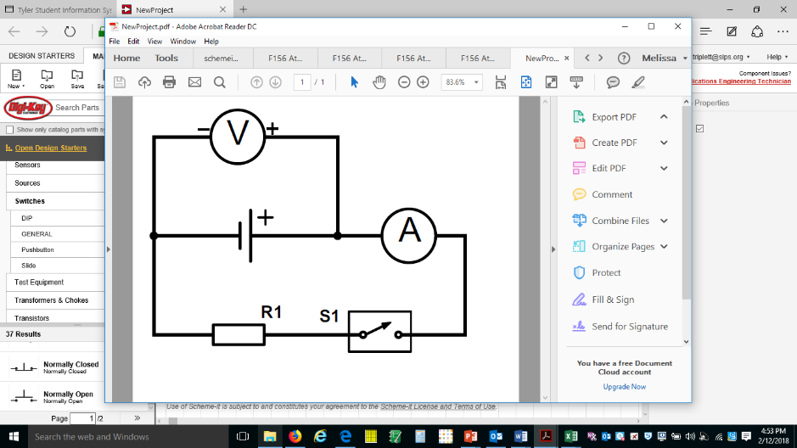A simple way to vary the current present in a circuit is to vary the resistance. In this experiment, you will connect a standard D battery to a series of simple resistors creating the circuit, shown above. A voltmeter and ammeter will be connected in parallel and series, respectively, to measure the potential and current of the circuit as the resistance of R1 is varied. (10 Ω, 20 Ω, 47 Ω, 100 Ω, and 220 Ω)

**Prelab:**

A 9.0 V battery has an internal resistance of 12.0 Ω.

(a) What is the potential difference across its terminals when it is supplying a current of 50.0 mA?

(b) What is the maximum current this battery could supply?

(c) Draw a sketch graph to show how the terminal potential difference varies with the current supplied if the internal resistance remains constant. How could the internal resistance be obtained from the graph?

**Materials:**

10 Ω, 20 Ω, 47 Ω, 100 Ω, and 220 Ω Resistors (Keep resistors with their labeled bag)

Multimeter to measure current

Vernier Sensor to measure voltage

D Battery power pack

Alligator clip wires to complete a circuit

Knife Switch

**Procedure:**

1. Construct the circuit shown above using one of the 5 types of resistors. (You may use the five in any order.)

2. Connect the black multimeter probe to the com. Connect the red probe to the mA socket. Set the dial to either the 20 mA or the 200 mA setting, using which ever will give you a three sigfig reading. (200 mA for all except the 220 Ω Resistor) Note that the reading will be in milliamps.

3. Close the switch and record a) the output voltage of the battery and b) the current in the circuit.

4. Open the switch when done recording to save battery life and avoid running down the battery. If your battery runs dry, you will have to start the experiment over with a fresh battery.

5. Return your first resistor back to its bag for others to use. Pick up a second resistor to measure and reconstruct the circuit.

6. Close the switch, make your measurements, open the switch. Change resistor. etc… until you have measured the current and potential for all 5 resistors.

**Data**

|  |  |  |  |
| --- | --- | --- | --- |
| **Resistor** | **Current (mA)** | **Potential (V)** | **Current (A)** |
| **10** Ω |  |  |  |
| **20** Ω |  |  |  |
| **47** Ω |  |  |  |
| **100** Ω |  |  |  |
| **229** Ω |  |  |  |

**Calculations:**

1. Plot Potential vs Current using the graph below.



2. Draw a best fit line.

3. Determine the equation of your best fit line. Show your work here.

4. From your best fit line, determine the EMF for the battery: ______________________

5. From your best fit line, determine the internal resistance for the battery: __________________

**Questions:**

1. A cell in a deaf aid supplies a current of 25.0 mA through a resistance of 400 Ω. When the wearer turns up the volume, the resistance is changed to 100 Ω and the current rises to 60 mA. What is the emf and internal resistance of the cell?
2. Explain why the headlamps of a car go dim when the starter motor is used.
3. A battery is connected in series with a variable resistor and an ammeter. When the resistance of the resistor is 10 Ω the current is 2.0 A. When the resistance is 5 Ω the current is 3.8 A. Find the emf and the internal resistance of the battery.
4. When a cell is connected directly across a high resistance voltmeter the reading is

1.50 V. When the cell is shorted through a low resistance ammeter the current is 2.5 A. What is the emf and internal resistance of the cell?

1. You are supplied with 6 identical dry cells, each of emf 1.5 V and internal resistance

0.3 Ω. What are the overall emf and internal resistance when:

1. the cells are connected in parallel?
2. the cells are connected in series?
3. they are connected in three groups, each of two cells in series, and these groups are connected in parallel with one another?